To Supply Leftover Food To Poor Using Salesforce

COLLEGE NAME : THAVATHIRU SANTHALINGA ADIGALAR ARTS SCIENCE AND TAMIL COLLEGE
COLLEGE CODE : BRU 20
TEAM ID : NM2025TMID20357
TEAM MEMBERS : 4
TEAM LEADER : RAKSHANA KP
EMAIL : raksharaksha125@gamil.com
TEAM MEMBER 1 : DEVIKA BS
EMAIL : devika.bs2830@gmail.com
TEAM MEMBER 2 : AKSHAYALAKSHMI T
EMAIL : akshayalakshmi271@gmail.com
TEAM MEMBER 3 : SREEJITH R
EMAIL : sreejith69004@gmail.com

Title:- To Supply Leftover Food To Poor
Using Salesforce…

Project Overview : Food wastage is a critical issue when large quantities of edible food are discarded while many people remain hungry. This project uses Salesforce CRM to build an application that manages the collection and distribution of leftover food. The system connects donors, drop-off points, volunteers, and NGOs to streamline the supply chain. With the help of custom objects, flows, triggers, and reports, the process is automated and transparent. The project demonstrates how technology can be applied to reduce food wastage and serve social welfare.

Objectives :

- Enhance Food Distribution Efficiency: Enable real-time tracking of leftover food collection and delivery to needy recipients.
- Ensure Transparency: Maintain accurate records of donations and recipient details to improve accountability.
- Improve Volunteer Coordination: Automate scheduling, notifications, and task assignments for volunteers.
- Optimize Resource Management: Track surplus food inventory and allocation for minimal waste.
- Enhance Real-Time Visibility: Provide live updates of available leftover food and its distribution status for donors, volunteers, and receivers.
- Promote Social Impact: Build a transparent and efficient system that encourages more participation from donors and volunteers in helping the poor.

Student Outcomes :

- Hands-on Experience with Food Distribution Automation: Students
gain practical skills in configuring Salesforce objects, automating workflows, and managing real-time donation tracking.
- Understanding of Project Lifecycle in Social CRM: Students learn the complete end-to-end process from requirement gathering to deployment, enhancing their ability to execute real-world Salesforce projects.
- Enhanced Analytical and Problem-Solving Skills: Students develop the ability to identify operational challenges, design solutions, and troubleshoot issues effectively.
- Improved Collaboration Skills: Students gain experience in working as a team, coordinating tasks like requirement gathering, development, and testing.
- Industry-Relevant Exposure: Students get exposure to real-world use cases of Salesforce CRM in social good projects, preparing them for future career opportunities.

System Requirements :

Hardware Requirements:

  - Computer with min/sum 4 GB RAM, Dual-core processor
  - Stable internet connection

Software Requirements:

  - Salesforce Developer Edition Org
  - Modern Web Browser (e.g., Google Chrome, Firefox)

Project Duration : 31 Hours;

Phases Overview :

Phase No. | Phase Name | Description | Page  Numbers
1 | Requirement  Analysis & Planning | Gathering requirements from donors, volunteers, and receivers; defining scope and goals; planning data model and workflows. | 4
2 | Salesforce  Development –  Backend &  Configurations | Creating custom objects, fields, relationships; setting up Flows and Apex Triggers for automation. | 4 - 11
3 | UI/UX Development & Customization | Building Lightning App, customizing layouts, adding fields, implementing Flows, and developing UI logic. | 11 - 28
4 | Data Migration, Testing & Security | Creating Users, Profiles, Public Groups, Sharing Rules; configuring Report Types, Reports, Dashboards; testing functionalities and ensuring data security. | 28 - 37
5 | Deployment,  Documentation &  Maintenance | Designing and finalizing Home Page, deploying solution to live environment, preparing documentation, conclusion, and ongoing system maintenance. | 37 - 40

Phase 1: Requirement Analysis & Planning:-

To Supply Leftover Food to Poor:
Utilizing Salesforce, our project streamlines surplus food collection and distribution to the needy, ensuring efficiency and transparency.

Phase 2: Salesforce Development – Backend & Configurations:-

Milestone 1: Salesforce developer account creation
Activity 1: Creating Developer Account
Creating a developer org in salesforce.
- Go tohttps://developer.salesforce.com/signup
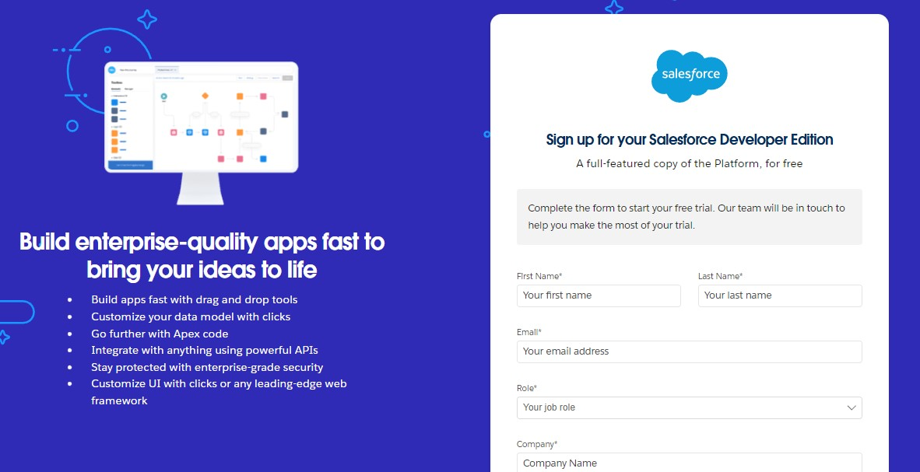
- On the sign up form, enter the following details :
  - First name & Last name
  - Email
  - Role : Developer
  - Company : College or Company Name
  - County : India
  - Postal Code : pin code
  - Username : should be a combination of your name and company This need not be an actual email id, you can give anything in the format :
username@organization.com
Click on sign me up after filling these.
Activity 2: Account Activation
1. Go to the inbox of the email that you used while signing up. Click on the verify account to activate your account. The email may take 5-10mins.
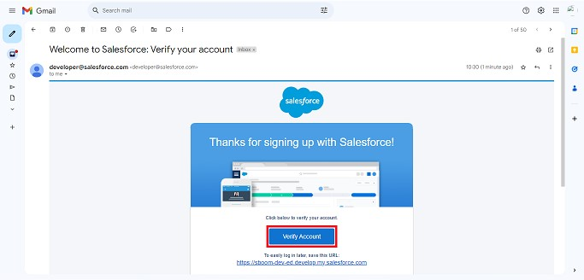
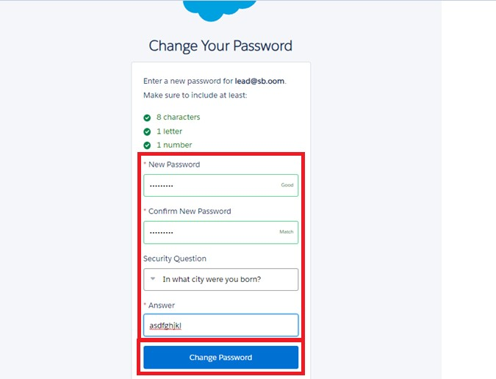

- Click on Verify Account
- Give a password and answer a security question and click on change password.
3.Then you will redirect to your salesforce setup page.
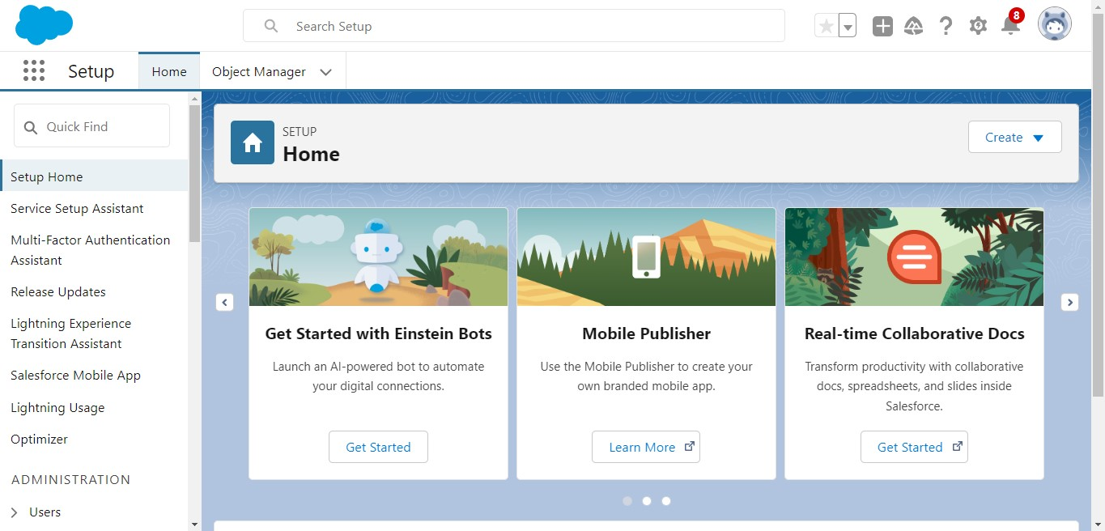

Milestone 2 : OBJECT :-
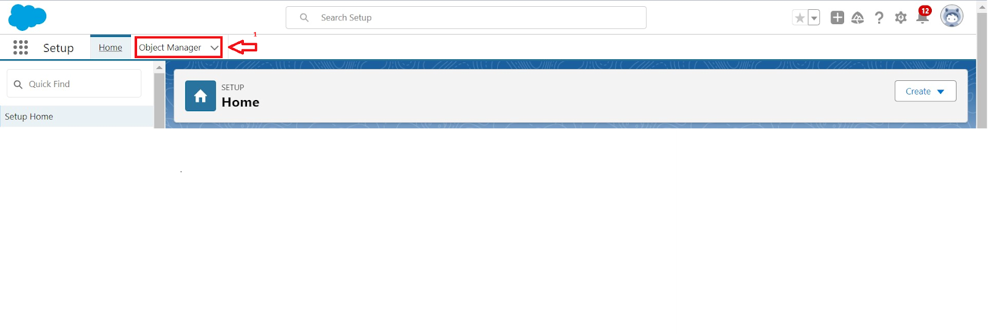
To

Navigate

to

Setup

page:

To create an object:
- From the setup page > Click on Object Manager > Click on Create > Click on Custom Object.
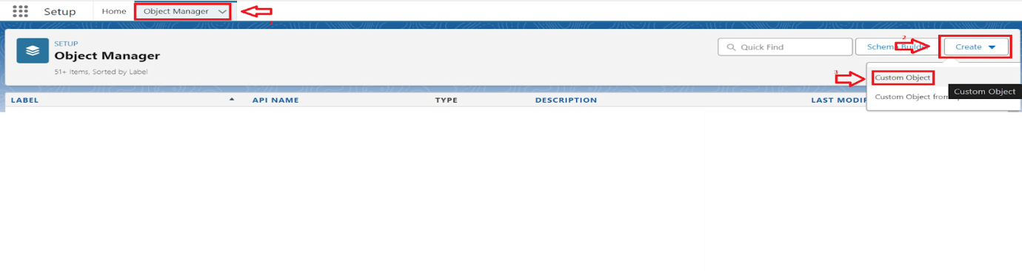
- On Custom object defining page:
- Enter the label name, plural label name, click on Allow reports, Allow search.

- Click on Save.

Activity 1: Create Venue Object:-
To create an object:
- From the setup page >> Click on Object Manager >> Click on Create >> Click on Custom Object.
  - Enter the label name >> Venue
  - Plural label name >> Venues
  - Enter Record Name Label and Format
    - Record Name >> Venue Name
    - Data Type >> Text
- Click on Allow reports and Track Field History,Allow Activities.
- Allow search >> Save.

Activity 2: Create Drop-Off Point Object:-
To create an object:
- From the setup page >> Click on Object Manager >> Click on Create >> Click on Custom Object.
  - Enter the label name >> Drop-Off Point
  - Plural label name>> Drop-Off Points
  - Enter Record Name Label and Format
    - Record Name>> Drop-Off point Name
    - Data Type >> Text
- Click on Allow reports and Track Field History,Allow Activities
- Allow search >> Save.

Activity 3: Create Task Object:-
To create an object:
- From the setup page >> Click on Object Manager >> Click on Create >> Click on Custom Object.
  - Enter the label name>> Task
  - Plural label name>> Tasks
  - Enter Record Name Label and Format
    - Record Name >> Task Name
    - Data Type >> Text
- Click on Allow reports and Track Field History,Allow Activities
- Allow search >> Save.

Activity 4: Create Volunteer Object:-
To create an object:
- From the setup page >> Click on Object Manager>> Click on Create >> Click on Custom Object.
a)Enter the label name>> Volunteer
b)Plural label name>> Volunteers
c)Enter Record Name Label and Format
  - Record Name >> Volunteer Name
  - Data Type >> Text
- Click on Allow reports and Track Field History, Allow Activities
- Allow search >> Save.

Activity 5: Create Execution Details Object:-
To create an object:
- From the setup page >> Click on Object Manager >> Click on Create >> Click on Custom Object.
a)Enter the label name >> Execution Detail
b)Plural label name >> Execution Details
c)Enter Record Name Label and Format
  - Record Name >> Execution Detail Name
  - Data Type >> Text
- Click on Allow reports and Track Field History, Allow Activities
- Allow search >> Save.

Milestone 3 : TABS :-
What is Tab : A tab is like a user interface that is used to build records for objects and to view the records in the objects.

Activity 1: Creating a Custom Tab:-
To create a Tab:(Venue)
- Go to setup page >> type Tabs in Quick Find bar >> click on tabs >> New (under custom object tab)
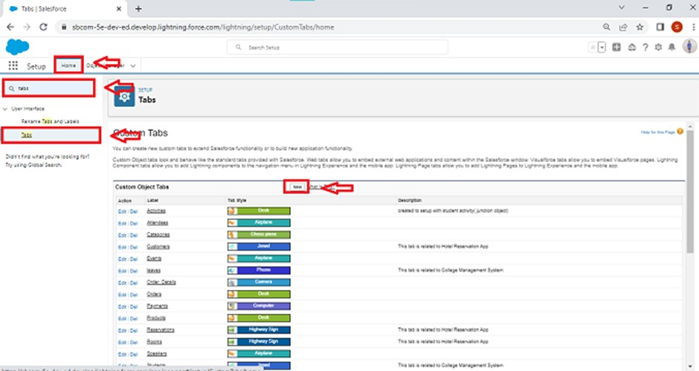

- Select Object(Venue) >> Select the tab style >> Next (Add to profiles page) keep it as default >> Next (Add to Custom App) uncheck the include tab .
- Make sure that the Append tab to users' existing personal customizations is checked.
- Click save.

Activity 2: Creating Remaining Tabs:-
- Now create the Tabs for the remaining Objects, they are “Drop-Off Point, Task, Volunteer, Execution Details”.
- Follow the same steps as mentioned in Activity -1.

Phase 3: UI/UX Development & Customization:

Milestone 4: THE LIGHTNING APP:- Create a Lightning App:

To create a lightning app page

- Go to setup page >> search “app manager” in quick find >> select “app manager” >> click on New lightning App.
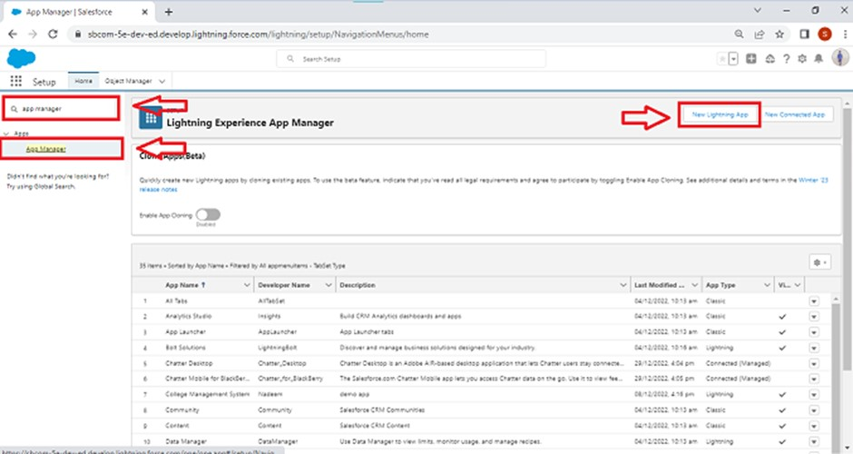
- Fill the app name in app details and branding as follow
  - App Name : FoodConnect
  - Developer Name : This will auto populated
  - Image : optional (if you want to give any image you can otherwise not mandatory)
  - Primary color hex value : keep this default.
3.Then click Next >> (App option page)Set Navigation Style as Standard Navigation >> Next.
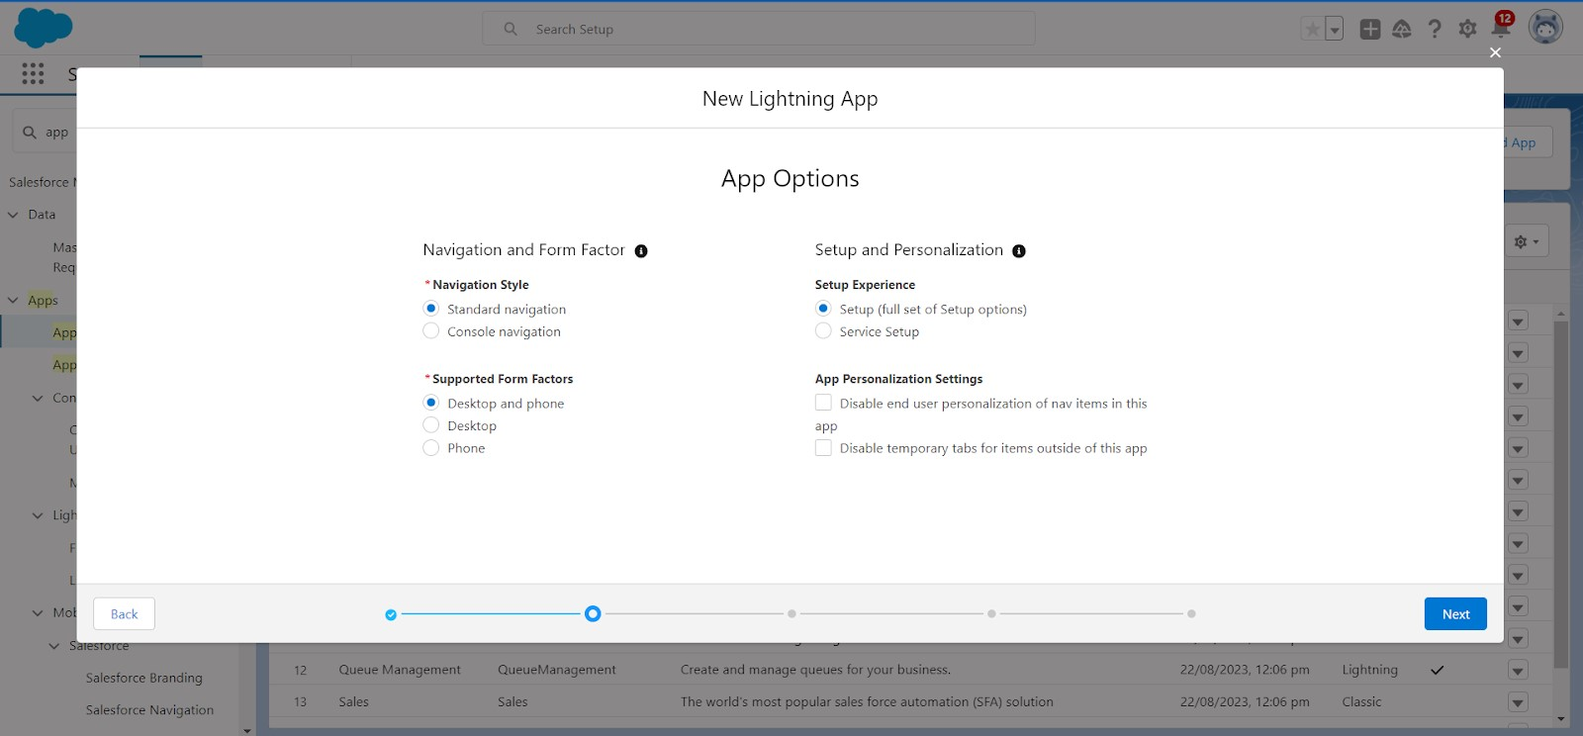
4.

(
Utility

Items)

keep

it

as

default

>>

Next.

5. To Add Navigation Items:
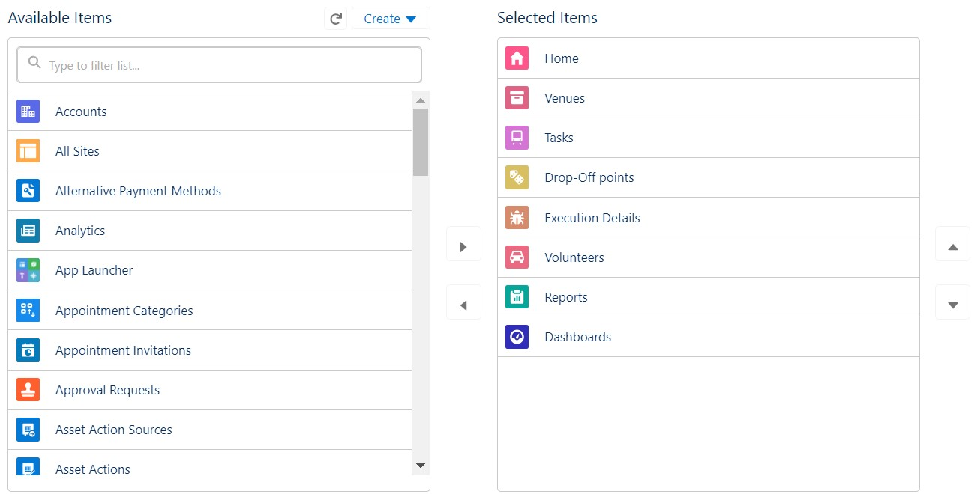
Search for the item in the (Home, Venue, Drop-Off Point, Task, Volunteer, Execution Details, Reports) from the search bar and move it using the arrow button >> Next >> Next.
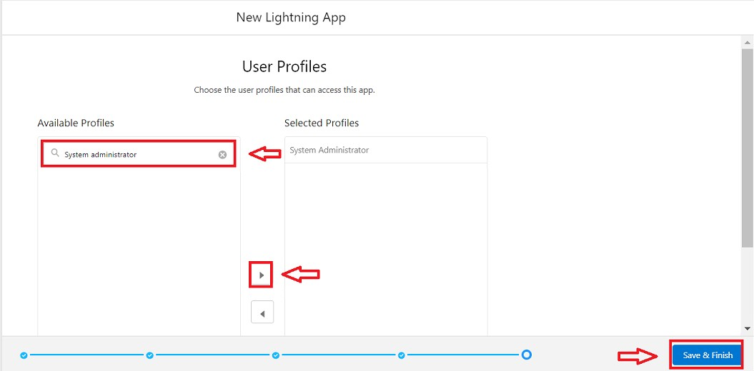
6.

To

Add

User

Profiles:

Search profiles (System administrator) in the search bar >> click on the arrow button >> save &finish.

Milestone 5: FIELDS :- Activity 1: Creation of Relationship Fields in Object:-
Creation of Lookup Relationship Field on Volunteer Object:
- Go to setup >> click on Object Manager >> type object name(Volunteer) in the search bar >> click on the object.
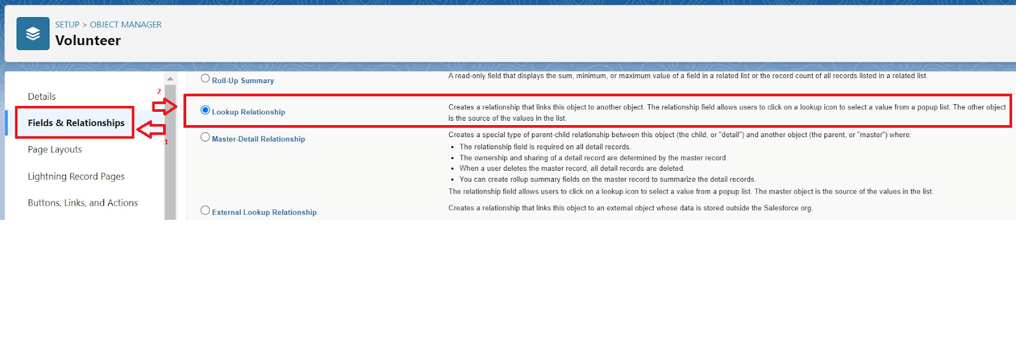
- Now click on “Fields & Relationships” >> New
- Select Master Detail relationship
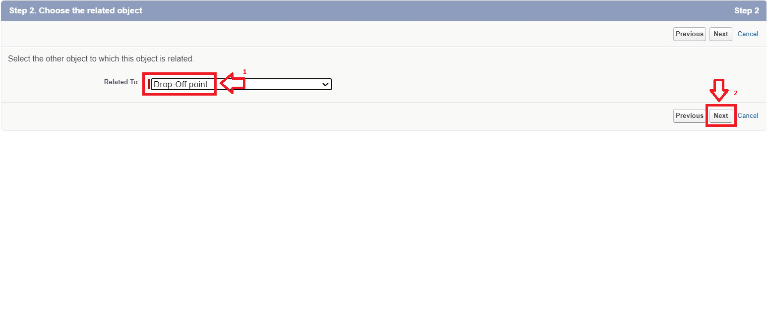
- Select the related object “Drop-Off point” and click next.
- Field Name : Drop_Off_point 6. Field label : Auto generated
- Next >> Next >> Save.

Creation of Master-Detail Relationship Field on Execution Detail Object:

- Go to setup >> click on Object Manager >> type object name(Execution Details) in the search bar >> click on the object.
- Now click on “Fields & Relationships” >> New
- Select Master Detail relationship
- Select the related object “Volunteer” and click next.
- Field Name : Volunteer
- Field label : Auto generated
- Next >> Next >> Save.

Creation of Master-Detail Relationship Field on Execution Detail Object:

- Go to setup >> click on Object Manager >> type object name(Execution Details) in the search bar >> click on the object.
- Now click on “Fields & Relationships” >> New
- Select Master Detail relationship
- Select the related object “Task” and click next.
- Field Name : Task 20. Field label : Auto generated
- Next >> Next >> Save.

Creation of Look-Up Relationship Field on Drop-off Point Object:

- Go to setup >> click on Object Manager >> type object name(Drop-Off Point) in the search bar >> click on the object.
- Now click on “Fields & Relationships” >> New
- Select Lookup relationship
- Select the related object “Venue” and click next.
- Field Name : Venue
- Field label : Venue__c 28. Next >> Next >> Save.

Creation of Lookup Relationship Field on Task Object:

- Go to setup>> click on Object Manager >> type object name(Task) in the search bar >> click on the object.
- Now click on “Fields & Relationships” >> New
- Select Lookup relationship
- Select the related object “Venue” and click next.
- Field Name : Sponsored By 34. Field label : Auto generated
- Next >> Next >> Save.

Creation of Lookup Relationship Field on Task Object:

- Go to setup>> click on Object Manager >> type object name(Task) in the search bar >> click on the object.
- Now click on “Fields & Relationships” >> New
- Select Lookup relationship
- Select the related object “Drop-Off point” and click next.
- Field Name : Drop-Off point 41. Field label : Auto generated
42. Next >> Next >> Save.

Activity 2: Creation of Fields for Venue Object:-

- Go to setup>> click on Object Manager >> type object name(Venue) in search bar >> click on the object.
- Now click on “Fields & Relationships” >> New 3. Select Data type as a “Email” and Click on Next
- Fill the Above as following:
  - Field Label : Contact Email
  - Field Name : Contact Email ● Click on required check box
  - Click on Next >> Next >> Save and new.

To create another fields in an object:
- Go to setup >> click on Object Manager >> type object name(Venue) in search bar >> click on the object.
- Now click on “Fields & Relationships” >> New 7. Select Data type as a “Phone” and Click on Next
- Fill the Above as following:
  - Field Label : Contact Phone
  - Field Name : Contact Phone
  - Click on required check box
  - Click on Next >> Next >> Save and new.
- Select Data type as a “Geolocation” and Click on Next
- Fill the Above as following:
  - Field Label : Location
  - Decimal Places : 4
  - Field Name : Location
  - Description : Enter the Geolocation of your Venue ● Click on Next >> Next >> Save and new.
- Select Data type as a “Long Text Area” and Click on Next
- Fill the Above as following:
  - Field Label : Venue Location
  - Field Name : Venue_Location
  - Click on Next >> Next >> Save and new.

Activity 3: Creation of Fields for Drop-Off Point Object:-

1.Go to setup >> click on Object Manager >> type object name(Drop-Off point) in search bar >> click on the object.
2. Now click on “Fields & Relationships” >> New 3. Select Data type as a “Geolocation” and Click on Next
4. Fill the Above as following:
- Field Label : Location 2
- Field Name : Gets auto generated.
- Description : Enter the Geolocation of the Drop off Point
- Geolocation Options : select Decimal
- Decimal Places : 4
- Click on Next >> Next >> Save and new.

To create another fields in an object:
- Go to setup >>click on Object Manager >> type object name(Drop-Off point) in search bar >> click on the object.
- Now click on “Fields & Relationships” >> New 3. Select Data type as a “Formula” and Click on Next
- Fill the Above as following:
  - Field Label : distance calculation
  - Field Name : distance_calculation
  - Formula Return Type : Number
  - Formula Options : DISTANCE( Location_2__c , Venue__r.Location__c , 'km')
  - Click on Next >> Next >> Save and new.
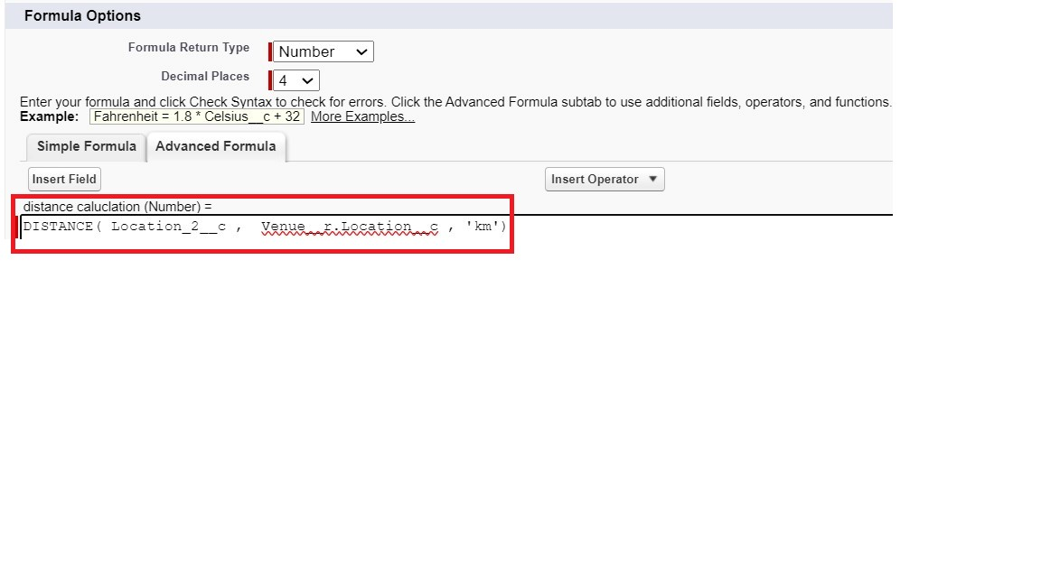
- Select Data type as a “Picklist” and Click on Next
- Fill the Above as following: ● Field Label : State
  - Field Name : State
  - Enter values, with each value separated by a new line :
Andhra Pradesh
Arunachal Pradesh
Assam
Bihar
Chhattisgarh
Goa
Gujarat
Haryana
Himachal Pradesh
Jharkhand
Karnataka
Kerala
Maharashtra
Madhya Pradesh
Manipur
Meghalaya
Mizoram
Nagaland
Odisha Punjab
Rajasthan
Sikkim
Tamil Nadu
Tripura
Telangana
Uttar Pradesh
Uttarakhand
West Bengal
Andaman & Nicobar (UT)
Chandigarh (UT)
Dadra & Nagar Haveli and Daman & Diu (UT)
Delhi [National Capital Territory (NCT)]
Jammu & Kashmir (UT)
Ladakh (UT)
Lakshadweep (UT)
Puducherry (UT) ● Click on required check box
● Click on Next >> Next >> Save and new.
- Select Data type as a “Number” and Click on Next
- Fill the Above as following: ● Field Label : Distance
  - Field Name : Distance
  - Length : 14
  - Decimal Places : 4
  - Click on required check box
  - Click on Next >> Next >> Save and new.

Activity 4: Creation of Fields for Task Object:-

- Go to setup>> click on Object Manager >> type object name(Task) in search bar >> click on the object.
- Now click on “Fields & Relationships” >> New 3. Select Data type as a “Auto Number” and Click on Next
4. Fill the Above as following:
- Field Label : Task ID
- Display Format : TASK-{0}
- Starting Number : 1
- Field Name : gets auto generated
- Click on required check box
- Click on Next >> Next >> Save and new.

To create another fields in an object:
- Go to setup >> click on Object Manager >> type object name(Task) in search bar >> click on the object.
- Now click on “Fields & Relationships” >> New 3. Select Data type as a “Date” and Click on Next
- Fill the Above as following:
  - Field Label : Date
  - Field Name : Date
  - Click on required check box
  - Click on Next >> Next >>Save and new.
- Select Data type as a “Picklist (Multi-Select)” and Click on Next
- Fill the Above as following:
  - Field Label : Food Category
  - Field Name : Food Category
  - Enter values, with each value separated by a new line :
Veg
Non-Veg
Salad
Snack
  - Click on required check box
  - Click on Next >> Next >> Save and new.
- Select Data type as a “Number” and Click on Next
- Fill the Above as following:
  - Field Label : Number of People Served
  - Field Name : Number_of_People_Served
  - Click on required check box
  - Click on Next >> Next >> Save and new.
- Select Data type as a “Text” and Click on Next
- Fill the Above as following:
  - Field Label : Name of the Person ● Field Name : Name_of_the_Person ● Click on Next >> Next >> Save and new.
- Select Data type as a “Phone” and Click on Next
- Fill the Above as following: ● Field Label : Phone
  - Field Name : Phone
  - Click on Next >> Next>> Save and new.
- Select Data type as a “Pick List” and Click on Next
- Fill the Above as following: ● Field Label : Rating
  - Field Name : Rating
  - Enter values, with each value separated by a new line :
1
2
3
4
5
  - Click on Next >> Next >> Save and new.
- Select Data type as a “Long Text Area” and Click on Next
- Fill the Above as following: ● Field Label : Feedback
  - Field Name : Feedback
  - Click on Next >> Next >> Save and new.

Activity 5: Creation of Fields for the Volunteer Object:-

- Go to setup >> click on Object Manager >> type object name(Volunteer) in search bar >> click on the object.
- Now click on “Fields &Relationships” >> New 3. Select Data type as a “Auto Number” and Click on Next
4. Fill the Above as following:
- Field Label : Volunteer ID
- Field Name : gets auto generated
- Click on required check box
- Click on Next >> Next >> Save and new.

To create another fields in an object:
- Go to setup >> click on Object Manager >> type object name(Volunteer) in search bar >> click on the object.
- Now click on “Fields & Relationships” >> New 3. Select Data type as a “Picklist” and Click on Next
- Fill the Above as following: ● Field Label : Gender
  - Field Name : Gender
  - Enter values, with each value separated by a new line :
Female Male
  - Click on Next >> Next >> Save and new.
- Select Data type as a “Date” and Click on Next
- Fill the Above as following:
  - Field Label : Available On
  - Field Name : Available On
  - Click on required check box
  - Click on Next >> Next >> Save and new.
- Select Data type as a “Number” and Click on Next
- Fill the Above as following: ● Field Label : Age
  - Field Name : Age
  - Click on required check box
  - Click on Next >> Next>> Save and new.
- Select Data type as a “Email” and Click on Next
- Fill the Above as following: ● Field Label : Email
  - Field Name : Email
  - Click on required check box
  - Click on Next>> Next >> Save and new.
- Select Data type as a “Number” and Click on Next
- Fill the Above as following:
  - Field Label : Contact Number
  - Field Name : Contact_Number
  - Click on required check box
  - Click on Next >> Next >> Save and new.
- Select Data type as a “Text Area (Long)” and Click on Next
- Fill the Above as following: ● Field Label : Address
  - Field Name : Address
  - Click on Next >> Next >> Save and new.
- Select Data type as a “Date” and Click on Next
- Fill the Above as following:
  - Field Label : Date of Birth
  - Field Name : Date_of_Birth
  - Click on Next >> Next >> Save and new.

Activity 5: Creation of Fields for the Execution Details Object:-

1.Go to setup >> click on Object Manager >> type object name(Volunteer) in search bar >> click on the object.
2. Now click on “Fields & Relationships” >> New 3. Select Data type as a “Auto Number” and Click on Next
4. Fill the Above as following:
- Field Label : Execution ID
- Field Name : gets auto generated
- Click on required check box
- Click on Next >> Next >> Save and new.

Milestone 6: FLOWS :-
Create Flow to create a Record in Venue Object:

1. Go to setup >> type Flow in quick find box >> Click on the Flow and Select the New Flow.
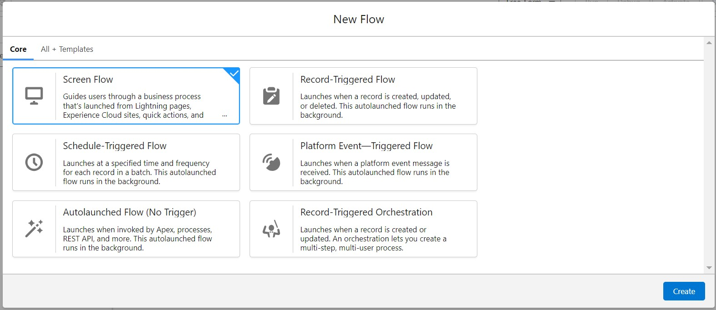
2.

Select

the

Screen

flow.

Click

on

create.

- Click on the ‘+’ icon in between start and end, and click on the screen element.
- Under the Screen Properties:
  - Label : Venue Details
  - API Name : Venue_Details
- Now let's add components in this flow. Click on Text Component and name it as:
  - Label : Venue Name
  - API Name : Venue_Name
- Click on Email Component and name it as:
  - Label : Email
  - API Name : Contact_Email
- Click on Phone Component and name it as:
  - Label : Phone
  - API Name : Contact_Phone
- Click on Text Component and name it as: ● Label : Venue Location
  - API Name : Venue_Location
- Click on Number Component and name it as:
  - Label : Latitude
  - API Name : Latitude
- Click on Number Component and name it as:
  - Label : longitude
  - API Name : longitude
- Next click on Done. This would like below
- Click on the ‘+’ icon in between Venue details and end, and click on create record element.
- Now label it as
    - Label : Create Venue Record
    - API Name : Create_Venue_Record
    - How Many Records to Create : One
    - How to Set the Record Fields : Use separate resources, and literal values
    - Object : Venue
    - Set Field Values for the Venue : Click on ‘Add Field’ 5 times
    - Field : Value = Contact_Email__c : {!Contact_Email.value}
    - Field : Value = Contact_Phone__c : {!Contact_Phone.value}
    - Field : Value = Name : {!Venue_Name}
    - Field : Value = Venue_Location__c : {!location}
    - Field : Value = Location__Latitude__s : {!latitude} ● Field : Value = Location__Longitude__s : {!longitude}
- This would look like:
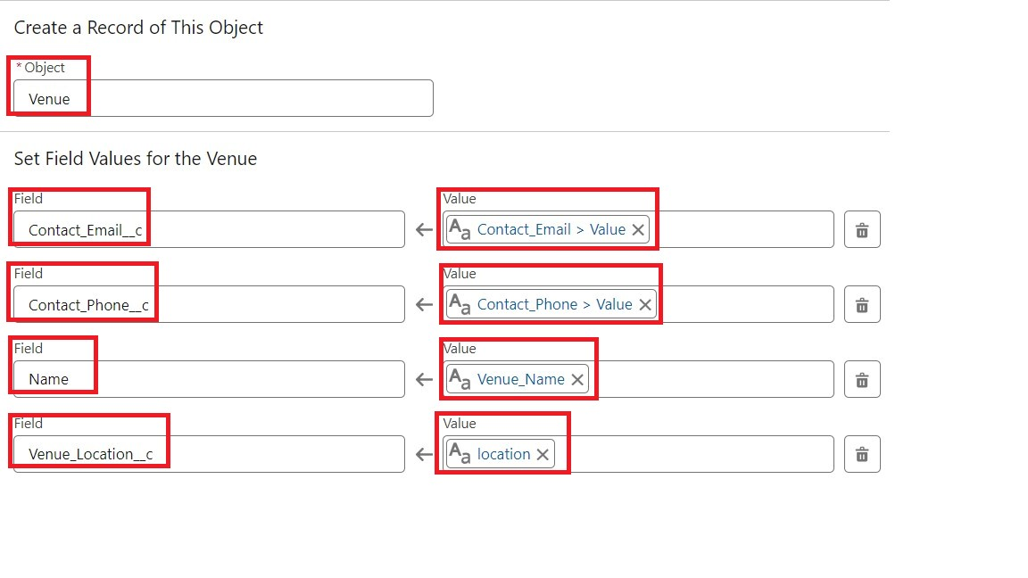
15.

Click

on

Save

as:

Flow

Label

:

Venue

Form

Flow API Name : Venue_Form

Milestone 7: TRIGGER :-
Activity 1: Create a Trigger :
- Log into the trailhead account, navigate to the gear icon in the top right corner.
- Click on developer console and you will be navigated to a new console window.
- Click on the File menu in the toolbar, and click on new >> Trigger.
- Enter the trigger name and the object to be triggered.
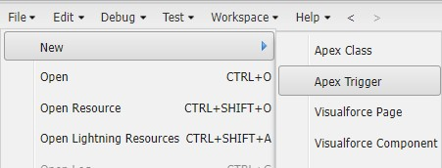

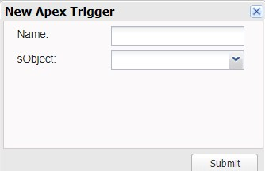

- Enter Name : DropOffTrigger sObject: Drop-Off Point__c
- Click on Submit.
Activity 2: Trigger Code :

(This Trigger is to assign the Distance field to the Distance Calculation field. So that we can assign the distance in the sharing rules.)

Code:
trigger DropOffTrigger on Drop_Off_point__c (before insert) { for(Drop_Off_point__c Drop : Trigger.new){
Drop.Distance__c = Drop.distance__c;
}
}

Phase 4 : Data Migration, Testing & Security Milestone 8 : PROFILES :-
- Go to setup page >> type Profiles in Quick Find bar >> click on Profiles >> click on ‘S’
- Click on Clone beside Standard Platform User.
- Under Clone Profile:
Profile Name : NGOs Profile
4.Then click on Save.

Milestone 9 : CREATION OF USERS :-

In our Project we consider them as NGO’s.

Activity 1: Creation of User1 :-
- Go to setup page >> type users in Quick Find bar >> click on users>> New user.
- In General Information give details as: (Note : create users as per your wish NGO’s)
  - First Name : Iksha Foundation
  - Last Name : Iksha_Foundation
  - Alias : iiksh
  - Email : Give Your Email
  - Username : ikshafoundation@sb.com (give the username different)
  - Nickname : Auto Populated
  - User License : Salesforce Platform
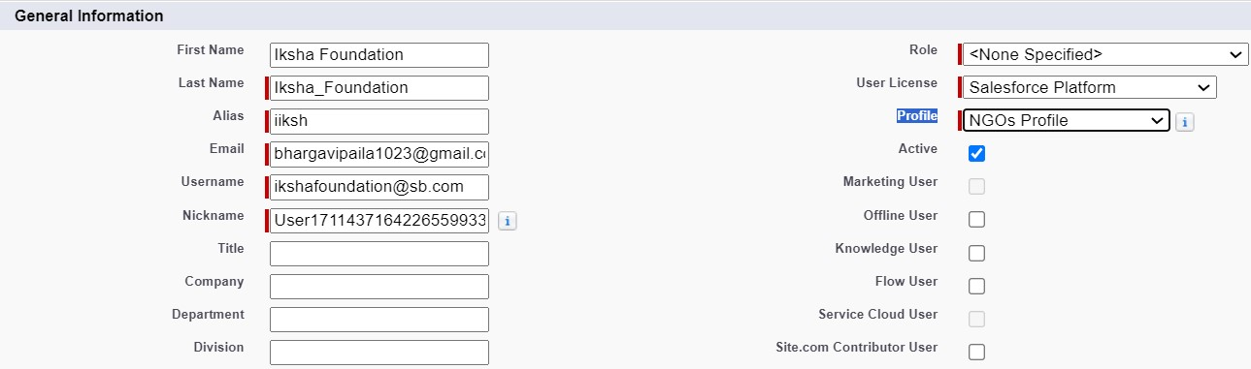
●

Profile

:

NGOs

Profile

●

Active

:

Check

3.

Click

on

Save.

Activity 2 : Creation of User2 and User3 :-

- Create another Two Users by following steps in Activity - 1 with similar User License and Profile.
- Give Different First Name, Last Name based on Different NGO’s.

10 PUBLIC GROUPS :-
Activity 1 : Creation of Public Group 1 :

- Go to setup page >> type Public Groups in Quick Find bar >> click on Public Groups >> click on New.
- Under Group Information: ● Label : Iksha
  - Group Name : Iksha
  - Grant Access Using Hierarchies : Check
- In Search, Select Users.
- In Selected Members Add Iksha Foundation.

Activity 2 : Creation of Public Group 2 and 3:-

- By Following Steps in Activity 1, Create other two Public Groups for other two users.
- After Saving this would look like this.

Milestone 11: REPORT TYPES :-

Activity 1: Creation of Venue with DropOff with Volunteer Reports :-

- Go to setup page >> type Report Types in Quick Find bar >> click on Report Types >> click on Continue >> Click on New Custom Report Type.
- In Define the Custom Report Type:
  - Primary Object : Select Venues
  - Report Type Label : Venue with DropOff with Volunteer
  - Report Type Name : Venue_with_DropOff_with_Volunteer
  - Description : Venue with DropOff with Volunteer
  - Store in Category : Select Other Reports
  - Deployment Status : Deployed
- Click on Next
- Near Click to relate another Object Select Drop-Off Points.
- And also select "A" records may or may not have related "B" records.
- Now again Near Click to relate another Object Select Volunteers.
- Now click on Save.

Activity 2 : Creation of Volunteers with Execution Details and Tasks :-

- Go to setup page >> type Report Types in Quick Find bar >> click on Report Types >> click on Continue >> Click on New Custom Report Type.
- In Define the Custom Report Type:
  - Primary Object : Select Volunteer
  - Report Type Label : Volunteers with Execution Details and Tasks
  - Report Type Name :Volunteers_with_Execution_Details_and_Tasks
  - Description : Volunteers with Execution Details and Tasks
  - Store in Category : Select Other Reports
  - Deployment Status : Deployed
- Click on Next
- Near Click to relate another Object Select Execution Details.
- And also select "A" records may or may not have related "B" records.
- Now click on Save.

12 REPORTS :-

Activity 1 : Creation of Report on Venue with DropOff with Volunteer :-

- Go to the app(FoodConnect) >> click on the reports tab
- Click on New Folder.
  - Folder Label : Custom Reports
  - Folder Unique Name : CustomReports
- Open Custom Reports and click on New Report 4. Select Report Type : Venue with DropOff with Volunteer
- Then click on Start Report.
- In GROUP ROWS : Add Volunteer Name
- In Columns : Add Venue Name, Drop-Off point Name, Distance.

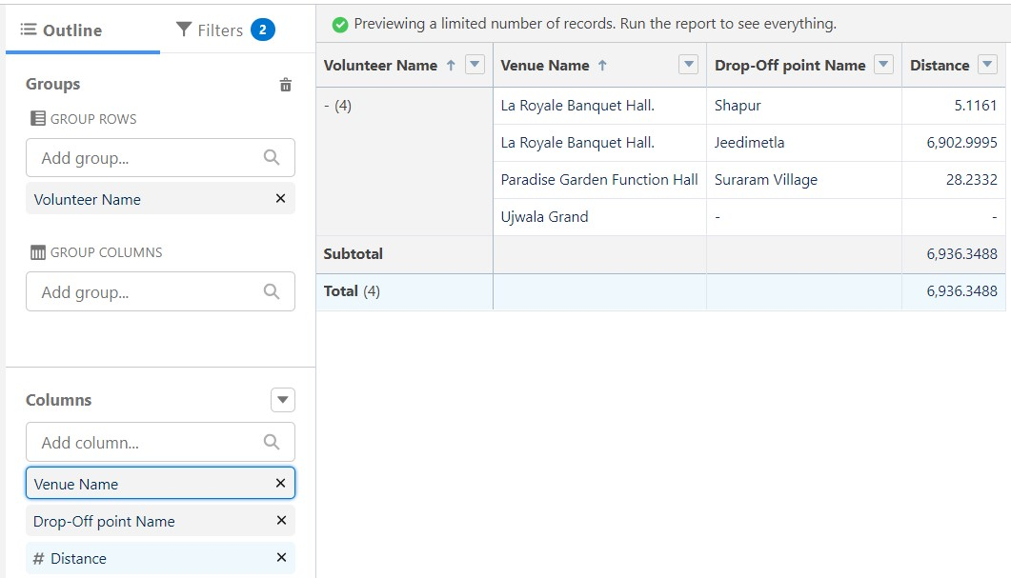

8.

Now

click

on

Save

&

Run.

- Give Label as :
- Report Name : venue and Drop Off point
- Report Unique Name : Auto Populated
- Click on Select Folder and select Custom Report, then click on Save.

Activity 2 : Creation of Report on Volunteers with Execution Details and Tasks :-

- Go to the app(FoodConnect) >> click on the reports tab
- Click on Custom Reports Folder and click on New Report 3. Select Report Type : Volunteers with Execution Details and Tasks.
- Then click on Start Report.
- In GROUP ROWS : Volunteer ID
- In Columns : Add Volunteer : Volunteer Name, Task : Task Name, Execution Detail Name, Created Date.
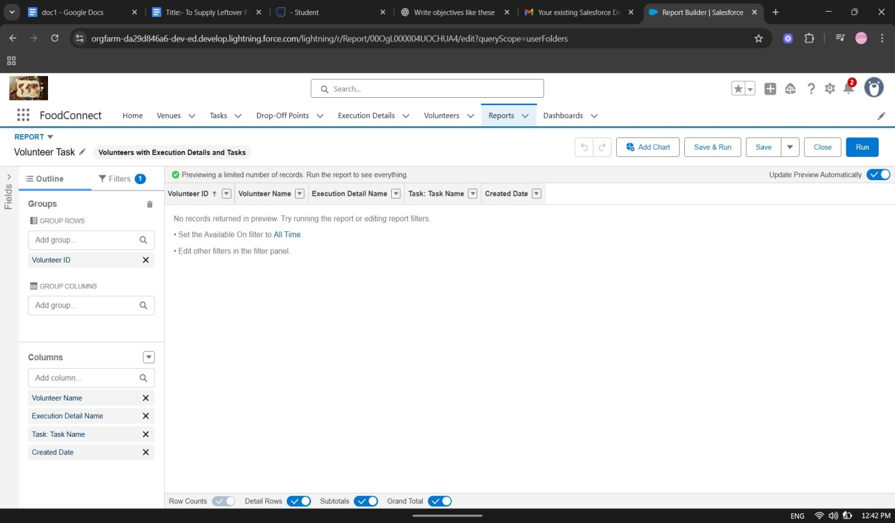

- Now click on Save & Run.
- Give Label as :
  - Report Name : Volunteer Task
  - Report Unique Name : Auto Populated
- Click on Select Folder and select Custom Report, then click on Save.

12 DASHBOARDS :-

Activity 1 : Adding venue and Drop Off point Report to the Dashboard :-

- Go to the app(FoodConnect) >> click on the Dashboards tab.
- Click on New Folder.
    - Folder Label : Custom Dashboards
    - Folder Unique Name : Auto Populated
- Open Custom Dashboards and click on New Dashboards
- Name : Organization Details
- Click on Widget and select Chart or Table
- In Select Report : Select venue and Drop Off point Report.
- Then click on select
- In Add Component:
  - Display As : Select Lightning Table
  - Component Theme : Select Dark (Optional)
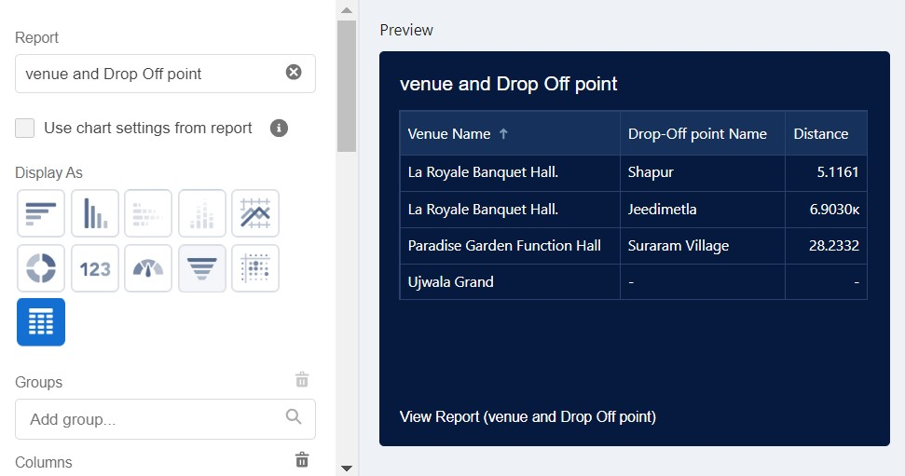
9.

Now

click

on

Save.

Activity 2 : Adding Volunteer Task Report to the Dashboard :-

1. Click on Widget and select Chart or Table 2. In Select Report : Select Volunteer Task Report.
- Then click on select
- In Add Component:
  - Display As : Select Line Chart
  - Component Theme : Select Dark (Optional)
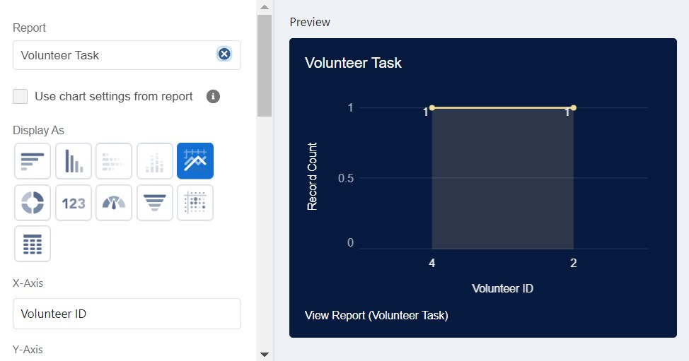
- Now Click on Save.

Activity 3: Adding a Picture to the Dashboard (Optional) :-

(Note : To upload an image into the Dashboard, we have to first download an image from google or other sources into your system)
- Click on Widget and select Image. Then click on Browse Files.
- Then Select the Picture you want to upload in this Dashboard.
- Then click on Save As :
  - Name : Task Execution Details

  - Click on Select Folder and select Custom Dashboards
- Click on Select Folder and then Save.
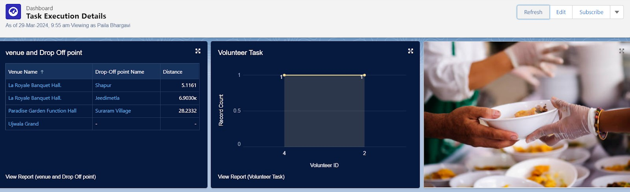

Milestone 13 : SHARING RULES :-

- Go to setup>> type Sharing Settings in quick find box >> Click on the Sharing Settings.
- Scroll down and find Drop-Off point Sharing Rules.
- Click on new near Drop-Off point Sharing Rules and Name it as:
  - Label : Rule 1
  - Rule Name : Rule_1
- Select your rule type : Select Based on criteria.
- Select which records to be shared:
  - Field : Operator : Value = Distance : less than : 15
- Select the users to share with : Near Share With
  - Public Groups : Iksha
- Click on Save.
- Click on new near Drop-Off point Sharing Rules and Name it as:
  - Label : Rule 2
  - Rule Name : Rule_2
- Select your rule type : Select Based on criteria.
- Select which records to be shared:
  - Field : Operator : Value = Distance : greater than : 15
  - Field : Operator : Value = Distance : less or equal : 30
- Select the users to share with : Near Share With
  - Public Groups : NSS
- Click on Save.
- Click on new near Drop-Off point Sharing Rules and Name it as:
  - Label : Rule 3
  - Rule Name : Rule_3
- Select your rule type : Select Based on criteria.
- Select which records to be shared:
  - Field : Operator : Value = Distance : greater than : 30
  - Field : Operator : Value = Distance : less or equal : 50
- Select the users to share with : Near Share With
  - Public Groups : Street Cause
- Click on Save.
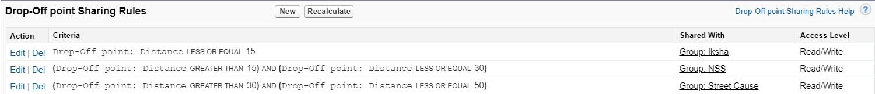

Phase 5 : Deployment, Documentation & Maintenance

Milestone 13 : HOME PAGE :-

Activity 1 : Creation of Home Page :-
- Go to setup >> type Lightning App Builder in quick find box >> Click on the Lightning App Builder and Select the New.
- Select Home Page and give Label as HOME Page.
- Select Standard Home Page.
- Near Components search for Flow and Drag and Drop in Right Side Section..
- On the right hand side:
● Flow : Venue Flow
- Near Components search for Dashboard, then Drag and Drop it in first Section.
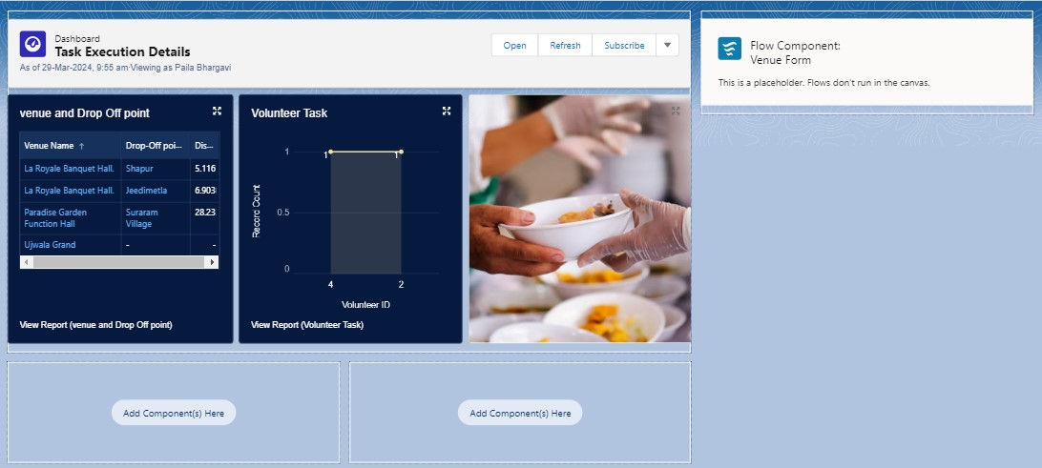
- Click on Save and Activation, then click on App Default, then Add Assignments.
- Add FoodConnect App and then Save.
- FoodConnect Home Page would Look Like this.
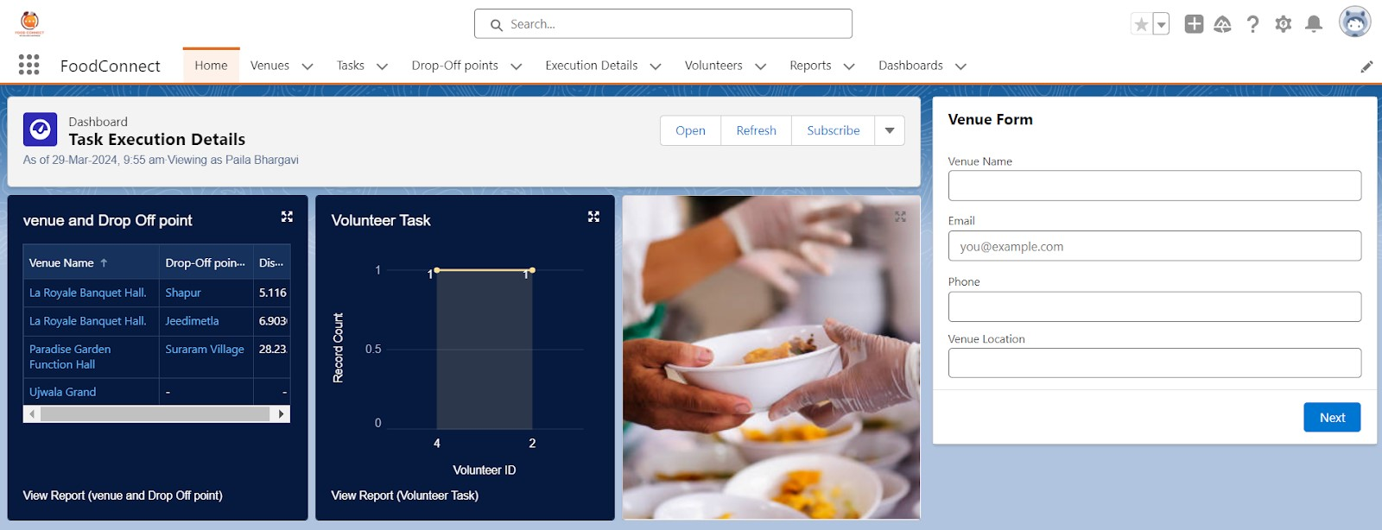

CONCLUSION :-

By leveraging the Salesforce platform, the project successfully established a streamlined and transparent system for managing surplus food donations. Through efficient coordination with volunteers and timely delivery to beneficiaries, the project effectively addressed food insecurity while maximizing the utilization of available resources.
The project “To Supply Leftover Food to Poor using Salesforce” has been successfully implemented and demonstrates the practical application of Salesforce CRM for social good.
- Project Achievements:

  - Streamlined the process of collecting and distributing leftover food.
○ Ensured real-time coordination between donors, volunteers, and NGOs.
○ Automated workflows through custom objects, fields, Flows, and Apex triggers.
○ Improved transparency using reports, dashboards, and sharing rules.
○ Enhanced usability with Lightning App, Home Page, and role-based security.

- Student Learning Outcomes:

  - Hands-on skills in Salesforce development and CRM customization.
○ Improved problem-solving through real-time use case implementation.
○ Team collaboration in handling requirement analysis, development, and testing.
○ Exposure to industry-relevant tools and project lifecycle management.
Future Scope:
- Integration with mobile platforms to allow easier donor and volunteer participation.
- Use of advanced analytics and AI to predict demand and optimize food distribution.
- Collaboration with more NGOs, hotels, and community centers for greater reach.
- Expansion to a multi-region system, ensuring maximum utilization of surplus food.

